Reimagining Pitch Lake in Trinidad: An Interactive Landmark
Enhanced with Technology

Elizabeth Elie
Department of Educational Technology, New Jersey City University
EDTC 8039103
Dr. Dana Mason
July 27, 2025

Introduction
Located in La Brea, Trinidad, Pitch Lake is the largest natural asphalt deposit in the world and a truly unique geological wonder. To boost its appeal as both an educational site and a tourist attraction, this proposal suggests a redesign that incorporates modern technology to create an interactive, safe, and inclusive experience. By applying good design practices, the new setup encourages learning through engaging multiple senses, providing instant feedback, and ensuring accessibility for all visitors.
Sound design and interactive learning tools can enhance a visitor’s experience by encouraging active exploration and knowledge building, as seen in constructivist learning theories (Piaget, 1952; Vygotsky, 1978). Norman’s design principles (2013) suggest that effective systems should be easy to discover, provide clear feedback, and focus on the user. To improve Pitch Lake digitally, these ideas could be applied through features like:
- Multimodal displays that include visuals, sounds, and touch-sensitive kiosks.
- Augmented Reality (AR) experiences that combine natural scenery with engaging stories.
- Haptic sensors that allow safe tactile interaction with samples or virtual objects.
- QR codes along trails for self-guided, mobile-based tours that help maintain social distancing.
These approaches help create an environment that feels natural and easy to use for a wide variety of visitors.
The main aim of the interactive Pitch Lake experience is to teach visitors about how the lake was formed geologically and its history, including topics like plate tectonics and the movement of hydrocarbons. It also aims to showcase the ecological importance and the challenges of maintaining biodiversity in tar-rich environments. The program also showcases indigenous cultural perspectives of the lake, including Amerindian folklore, and promotes environmental responsibility by highlighting sustainable methods for harvesting asphalt. In line with Bloom’s Taxonomy, these objectives include understanding through explanatory videos and augmented reality overlays, applying and analyzing via interactive geological simulations, and creating by having students develop their own digital posters or presentations after their visit.
Rationale and Relevance
Pitch Lake is an underused resource in both regional tourism and global science education, and transforming it in this way would make the site competitive worldwide with other natural attractions that have already leveraged technology, such as Yellowstone National Park or the geyser fields of Iceland. A redesigned experience would also be far more accessible and welcoming to children, seniors, and individuals with disabilities, groups that are currently limited by the terrain and the largely unguided nature of the site. Rather than treating accessibility as an accommodation added at the end, the proposed design builds it into the visit itself through narrated tours, enlarged text, seated viewing areas, and alternative routes that deliver the same content to every visitor.
Beyond the visitor experience, the project would act as a driving force for local economic growth. Installing and maintaining kiosks, sensors, and mobile applications would create technology jobs in the surrounding communities, while expanded guided tours and app-based support services would give nearby residents additional sources of income tied directly to the landmark. The design is also especially relevant in a post-COVID world, because self-guided mobile tours, QR-code trail markers, and contactless kiosks allow visitors to move through the site at their own pace, encouraging physical distancing without reducing the depth of engagement.
Finally, the proposal is sustainable in both environmental and financial terms. Using locally sourced materials and solar power to run the kiosks would keep ongoing operating costs low, which matters for a public site that must justify its budget year after year. Taken together, these factors make a strong case that the investment would be recovered through increased tourism, educational partnerships, and long-term community benefit.
Training local guides as digital docents combines traditional storytelling with AR-enhanced tours. The site requires minimal excavation or alterations, ensuring environmental safety and preservation. It aligns well with initiatives from the Ministry of Tourism and Education to promote STEAM learning.
Participant Case Example
Case 1: Student Field Trip (Grades 6–8)
When students arrive, they are given AR tablets. At the entrance, they are greeted by a 3D projection of an Amerindian guide. As they walk along the trail, sensors activate audio and animations. One station shows tar bubbling under their feet, then they answer a quiz about how tar was used in ancient times. At the kiosk, students combine virtual elements like soil, oil, and heat to see how pitch forms. The visit concludes with a digital certificate and a group discussion about sustainable tourism.
Case 2: Elderly Visitor With Limited Mobility
A retiree uses the Virtual Companion App from a shaded, wheelchair-accessible area. By scanning a QR code, they enjoy a narrated virtual tour. The AR model lets them see ancient fossils found in the lake. With enlarged text and voice narration, they can fully participate without walking the trail.
Visual Model
Figure 1
Proposed Interactive Design Concept for Pitch Lake
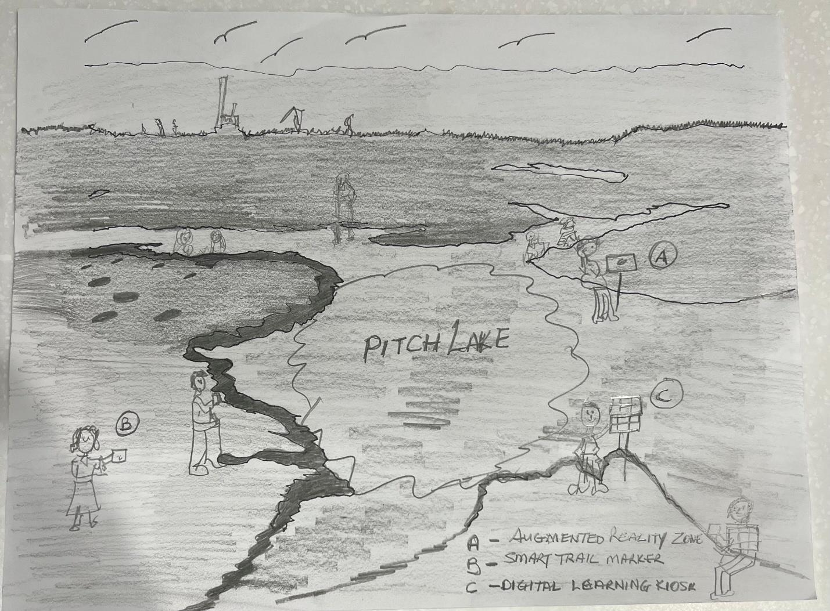
Note. A – Augmented Reality Zone; B – Smart Trail Marker; C – Digital Learning Kiosk. Original sketch by the author.
Conclusion
In conclusion, Pitch Lake in Trinidad offers far more than natural asphalt. With the integration of modern technology, it can become a global model of sustainable innovation, intelligent resource use, and immersive education. By embracing technological transformation, Trinidad and Tobago can secure a forward-looking future while preserving and showcasing the rich natural heritage of one of its greatest national treasures.

References
Norman, D. A. (2013). The design of everyday things: Revised and expanded edition. Basic Books.
Piaget, J. (1952). The origins of intelligence in children. International Universities Press.
Vygotsky, L. S. (1978). Mind in society: The development of higher psychological processes. Harvard University Press.

