Memorandum
To: Dr. Chayo
From: Elizabeth Elie, Researcher
Date: August 17, 2025
Subject: K–12 Enrollment Trends: 1985, 1995, and 2005
Purpose
This memorandum provides an overview of trends in U.S. K–12 enrollment across a 20-year period, from fall 1985 through fall 2005, using data from the National Center for Education Statistics (NCES). It examines shifts in both public and private school attendance, identifies the patterns visible in those shifts, and offers recommendations to help with future planning.
Figure 1
K–12 Enrollment in Public and Private Schools, 1985–2005
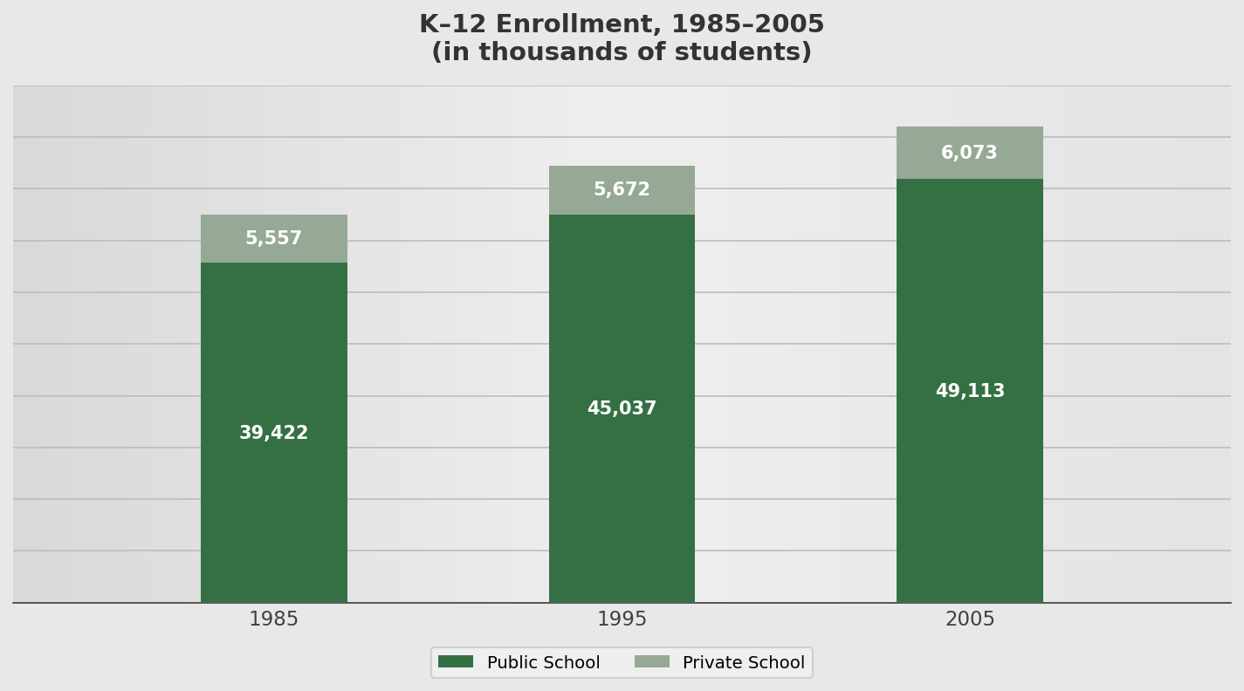
Note. Figures are in thousands of students. Public and private figures for 1985 and 1995 are from NCES (1995); 1995 values are NCES projections. The 2005 public figure is from NCES (2007) and the 2005 private figure is from NCES (2017).
Overview and Insights
Total K–12 enrollment grew substantially over the two decades examined. Public school enrollment rose from 39,422 thousand students in fall 1985 to 45,037 thousand in fall 1995 and 49,113 thousand in fall 2005, a net gain of 9,691 thousand students, or approximately 24.6 percent. Private school enrollment grew far more modestly over the same period, from 5,557 thousand to 5,672 thousand and then to 6,073 thousand, a net gain of 516 thousand students, or approximately 9.3 percent. Combined enrollment across both sectors increased from 44,979 thousand to 55,186 thousand, a gain of 10,207 thousand students (NCES, 1995, 2007, 2017).
Three patterns emerge from these figures. First, public schools absorbed nearly all of the growth. Of the 10,207 thousand additional students enrolled between 1985 and 2005, roughly 94.9 percent entered public schools, which means that essentially the entire increase in demand for classrooms, teachers, and facilities fell on publicly funded systems. Second, the pace of that growth was uneven across the two decades. Public enrollment climbed by 5,615 thousand students between 1985 and 1995 but by 4,076 thousand between 1995 and 2005, indicating that the steepest expansion occurred in the first ten years and then began to moderate. Planning based on the 1985 to 1995 rate alone would therefore have overstated later demand.
Third, the private sector's share of total enrollment contracted slightly, from 12.4 percent in 1985 to 11.2 percent in 1995 and 11.0 percent in 2005. Private enrollment did not decline in absolute terms; it simply grew more slowly than public enrollment. As Figure 1 illustrates, the private segment of each bar remains close to constant in height while the public segment lengthens noticeably, which is the visual signature of a sector growing in absolute numbers while losing relative share.
The upward trend in K–12 enrollment signals not only a demand for more educational infrastructure, but also a need to evaluate how effectively current systems serve diverse and changing populations. Without proactive planning and investment, the system risks being overextended, potentially leading to overcrowded classrooms, staffing shortages, and unequal learning conditions.
Recommendations
To keep up with the ongoing increase in K–12 student enrollment, it is important to expand school facilities and hire more staff. Efforts should be directed toward constructing new schools, improving existing buildings, and bringing in more qualified teachers and support staff to handle the rising numbers. Additionally, examining regional trends at the state and district levels can help identify areas experiencing the fastest growth and ensure resources are distributed more fairly.
It is also vital to understand how differences in local and state funding impact student outcomes, as disparities can limit access to advanced classes and support services. Federal data support this concern directly: national findings from the Civil Rights Data Collection show that high schools serving the highest proportions of Black and Latino students offer advanced mathematics and science courses at measurably lower rates than high schools nationally (U.S. Department of Education, Office for Civil Rights, 2018). To make informed decisions, future studies should monitor long-term enrollment trends, evaluate the success of policy measures, and explore how demographic shifts influence schools.
Above all, equity should remain a central focus, and the enrollment data in Figure 1 explain why. Because public schools absorbed approximately 95 percent of the net enrollment growth between 1985 and 2005, the burden of accommodating additional students fell almost entirely on the systems most dependent on public funding formulas. When enrollment rises faster than funding, that strain does not distribute evenly across districts. It concentrates in communities with the weakest local tax bases, which are frequently the same communities least able to add classrooms, recruit certified teachers, or sustain advanced course offerings (U.S. Department of Education, Office for Civil Rights, 2018). The national totals in Figure 1 therefore conceal an important distributional question. A net increase of 9,691 thousand public school students is manageable if capacity expands where those students actually live, and damaging if it does not.
For this reason, policy responses to these trends should be evaluated not only by whether total capacity keeps pace with total enrollment, but by whether capacity grows in the specific communities absorbing the largest increases. Enrollment projections disaggregated by state and district, paired with measures of funding adequacy, would allow planners to identify those communities in advance rather than after classrooms are already overcrowded. A logical next step for this project would be to extend the national picture presented in Figure 1 using state-level Common Core of Data enrollment figures, which would convert these aggregate trends into the district-level detail that staffing and construction decisions actually require.
References
National Center for Education Statistics. (1995). Mini-digest of education statistics 1995: Enrollment. U.S. Department of Education. https://nces.ed.gov/pubs/MiniDig95/enroll.asp
National Center for Education Statistics. (2007). Table 1. Public school student membership, by grade and state or jurisdiction: School year 2005–06 (NCES 2007-352). U.S. Department of Education. https://nces.ed.gov/pubs2007/pesenroll06/tables/table_1.asp
National Center for Education Statistics. (2017). Table 205.80. Private elementary and secondary schools, enrollment, teachers, and high school graduates, by state: Selected years, 2005 through 2015. In Digest of education statistics 2016. U.S. Department of Education. https://nces.ed.gov/programs/digest/d16/tables/dt16_205.80.asp
U.S. Department of Education, Office for Civil Rights. (2018). 2015–16 civil rights data collection: STEM course taking. https://civilrightsdata.ed.gov/assets/downloads/stem-course-taking.pdf

